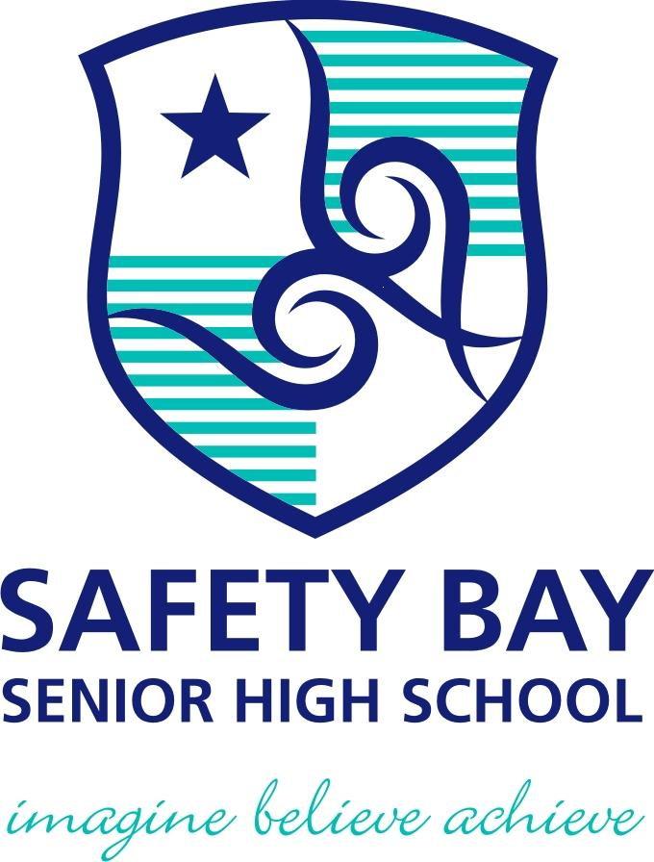

YEAR: 8
SUBJECT: SCIENCE

TEST: Physical and chemical change
TIME: 55 mins
QUESTIONS: Part A: Multiple Choice Questions (10 marks)
Part B: Short Answer Questions (32 marks)

TOTAL MARKS: 42 marks

DO NOT WRITE ON OR MARK THIS PAPER
Part A: Multiple Choice Questions (1mark each)
Answer this section on the separate multiple – choice answer sheet

1. Which of the following is a chemical change?

- Sawdust is produced from wood being cut by a power saw.
- Water freezes to form ice.
- Fireworks explode in a colourful light display.
- Juice is obtained from an orange.
2. A permanent colour change may be an indication that a chemical reaction has taken
place. Identify which of the following is not an indication of a chemical reaction.

- sugar caramelising
- toast bread
- a glass breaking
- burning a match

3. The substances that you begin within a reaction is called as
- reactants.
- products.
- elements.
- compounds.

4. Which of the following would NOT be a physical change?

- freezing water to make ice cubes
- melting gold to make jewellery
- burning gasoline in a lawnmower
- boiling water for soup
5. The term corrosion means:

- coating iron with a material such as paint
- a chemical reaction where a metal reacts with oxygen
- a chemical reaction where oxygen is a product
- is coating iron with zinc metal

6. The Law of Conservation of Mass states that ‘During a chemical reaction, atoms are
neither created nor destroyed’. This law suggests that if a chemical reaction occurred
inside a closed container, the total mass of the container and its contents would:

- increase as more chemicals are produced by the reaction.
- decrease if the chemical reaction produces a gas.
- stay the same.
- increase or decrease depending on the type of chemical reaction.
7. Joe collected some snow and placed it in a beaker. During the day it melted to produce
clear water. Joe and his friends made the following comments about the process.

Joe: This is a chemical change as there is a change in colour.
Jill: The beaker is now warmer than when you collected the snow. This must be a
chemical change as energy is absorbed.
Jenny: This is a physical change as the trapped air bubbles react with the snow.
Jamal: This is a physical change as no new substances are created.
State who you believe is correct.

- Joe
- Jill
- Jenny
- Jamal

8. Analyse the word equation:
methane + oxygen → carbon dioxide + water + energy
This reaction shows that:

- oxygen is a product of this reaction.
- methane burns with a sooty flame.
- this is an exothermic reaction.
- a constant input of energy is required to keep the reaction going.

9. Identify which of the following would indicate an endothermic reaction.

- a gas is given off
- the reaction glows
- a precipitate forms
- the reaction feels cold to the touch

10. The recycling of aluminium can be considered a series of physical changes as shown
by the flow diagram below.

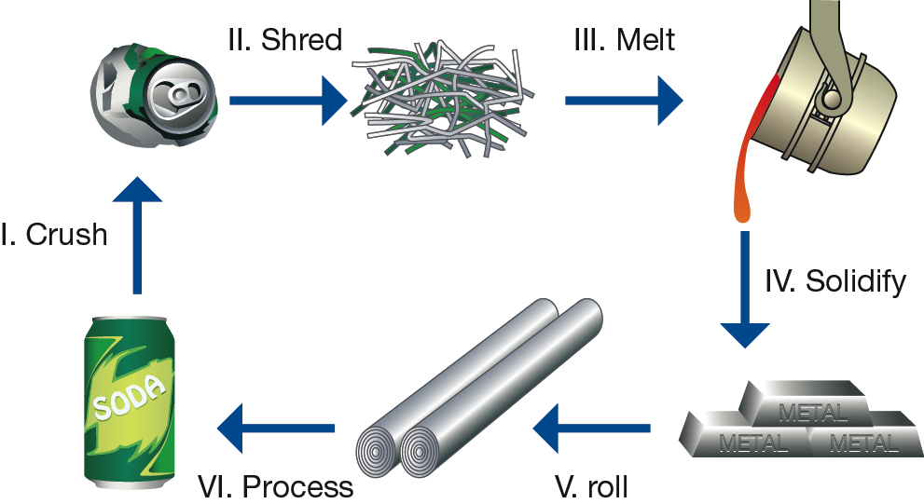

Which stages of the aluminium recycling process would be considered a change of state?

- I and II
- II and III
- III and IV
- only III

YEAR: 8
SUBJECT: SCIENCE
Name__________________________________________________
Form ____________

TEST: Physical and chemical change
TIME: 55 mins
QUESTIONS: Part A: Multiple Choice Questions (10 marks)
Part B: Short Answer Questions (32 marks)

TOTAL MARKS: 42 marks

Part A: Multiple Choice Answers (1mark each)
Put a cross (X) through the correct answer.

1 a b c d
2 a b c d
3 a b c d
4 a b c d
5 a b c d
6 a b c d
7 a b c d
8 a b c d
9 a b c d
10 a b c d

Marks

Part A: Part B:
Multiple Choice Short Answer Total

/10
/20

/32

/42

Part B: Short Answer Questions
11. Define the term precipitation.
Precipitation will occur when two solutions are mixed together or when a gas is bubbled through a liquid.
(Any idea similar to above - 1mark)
12. Label each process as a physical or chemical change: (6 marks)
Slicing potatoes for fries | physical
A nail rusting | chemical
Baking cookies | chemical
Butter melting | physical
Food spoiling | chemical
You cut your hair | physical

13. Write word equations for the following chemical reactions. (2 marks)
a) Hydrogen gas and oxygen gas combine to form water.
Hydrogen gas + oxygen gas  water
b) Heating copper carbonate forms copper oxide and carbon dioxide.
copper carbonate + heat  copper oxide + carbon dioxide
14. a) Explain the difference between the terms reactants and products. (2 marks)
Reactants: substances present at the beginning of a reaction or substances present at
the left hand side of the arrow of a word equation representing the reaction.
Products: Substances that are produced at the end of a reaction or substances
represented at the right-hand side of the arrow of a word equation representing the
reaction. ( Answer similar to above give one mark each)

b) When magnesium metal reacts with hydrochloric acid, hydrogen gas and magnesium
chloride are formed. Identify the products and reactants of this reaction. (2 marks)

Products: hydrogen gas and magnesium chloride
Reactants: Magnesium metal and hydrochloric acid (1 mark each)

15. Contrast the terms endothermic and exothermic reactions and give at least two examples
of each of them.

Endothermic: Describes a process that absorbs energy from the surroundings. (1 mark)
e.g. ice pack or ammonium nitrate and water reaction, sodium thiosulfate with water,
evaporation etc ( Any two suitable examples ---- no explanation needed) (1 mark)

Exothermic: Describes a process that gives off energy in the form off heat, light or sound.
(1 mark)
e.g. fireworks, sparklers, firing a bullet, burning magnesium ribbon, condensation etc ( Any two suitable examples ---- no explanation needed) (1 mark)
16. Complete the table below by filling in answers for parts a) to h) (8 marks)
Name | Formula
Water | a) H₂O
b) Hydrogen gas | H₂
Hydrochloric acid | c) HCl
d) Potassium | K
Carbon dioxide | e) CO₂
f) Chlorine gas | Cl₂
Sodium chloride | g) NaCl
h) Sulfur trioxide | SO₃

17. Define the term corrosion. List at least three methods to prevent rusting and explain each of these methods in your own words. (1+ 3 + 3 marks)
The term corrosion refers to chemical reactions where a metal reacts with oxygen. (I mark)

Three methods are coating, galvanising and alloying ( 3 marks)
Coating: A way to protect iron from rusting is to coat the iron with a material such as paint, plastic or another metal such as chromium. (I mark)

Galvanising: If the iron is coated with zinc metal, then the zinc coating will continue to protect the iron even if the coating is scratched or cracked. (I mark)

Alloying: Pure iron is too soft and undergoes corrosion rapidly. For this reason it is usually mixed with carbon and other metals to produce steel, which is harder and more resistant to corrosion.

Or some metals are too soft and undergo corrosion rapidly, to prevent this these metals are mixed with other metals or carbon to make it harder and corrosion resistant. This process is known as alloying. (I mark)

END OF TEST

